**HOW TO GET TO COIMBRA**

Fly to Lisbon airport or to Porto airport.  
  
Lisbon is 200 km from Coimbra  
Porto is 110 Km from Coimbra  
  
From both airports you can reach Coimbra by train.

1. From Lisbon airport:

1.1 take the metro (**red line**, see picture below) from the airport to "Oriente railway station in Lisbon - **Estação do Oriente**"

1.2 from "**estação do Oriente**" catch the train to Coimbra (***Coimbra b***) - fast train takes 1 h 40 min to Coimbra

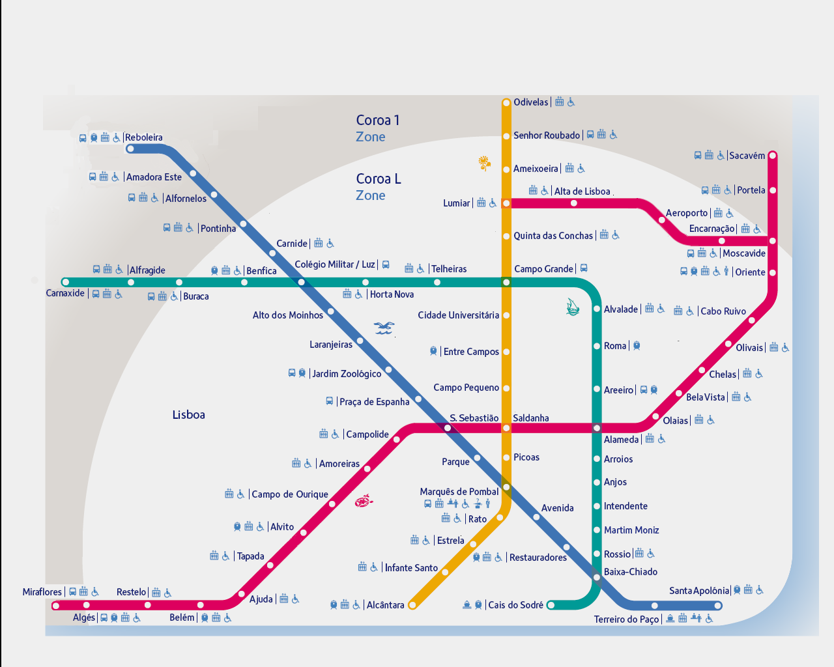

1. From Porto airport:

2.1 take the metro to railway station "**Estação Campanhã**", **metro  line E (purple)**

2.2 from "**estação Campanhã - Porto**", take the train to Coimbra (***Coimbra b***) - fast train takes 1 hour to Coimbra

**CLICK ON THE MAP TO ENLARGE!**

Train time tables can be found at: <http://www.cp.pt/cp/displayPage.do?vgnextoid=a4f6f9e12a584010VgnVCM1000007b01a8c0RCRD>  
<http://www.cp.pt8c0RCRD> (also in english).  
  
Once in ***Coimbra b*** the best option is to take a taxi to the hotel (cost: approx 5 to 6 Euros).

**HOW TO GET TO THE WORKSHOP/MEETING VENUE**



**DOUBLE CLICK ON THE ICON!! ->**

NOTES: From hotels in the city center, the best option is to take a taxi (approx fare: 5 EUR maximum).

Going by bus is possible but always implies changing bus to catch the bus which goes to the university.

**LIST OF SUGGESTED HOTELS**

Hotels (prices are relative to the first week of March and can be changed by the hotel management)

**NOTE: Flat rate reimbursement for this meeting will be 80 EUR/night!!**

* **Hotel Ibis Coimbra Centro** - 39 EUR single room one bed + 6 EUR for breakfast, walking distance from the meeting venue (approx 3 km)

(website: <www.ibishotel.ibis.com>)

* **Hotel Dona Ines** -  49 EUR single room one bed + 6 EUR for breakfast

(website: <http://www.hotel-dona-ines.pt/index.php?lang=en>)

* **Hotel Vila Galé Coimbra** – 58 EUR single room one bed + 7.5 EUR for breakfast

(website: <http://www.vilagale.co.uk/index.php?lang=2>)

* **Hotel D. Luis** – 41EUR single room one bed + 11? for breakfast

(website: <http://www.hoteldluis.pt/index.php?lang=en>)

For further information and assitance, please contact the Local Organizers:

Maria Graça Rasteiro ([mgr@eq.uc.pt](mailto:mgr@eq.uc.pt))

Pedro Faia ([faia@deec.uc.pt](mailto:faia@deec.uc.pt))

**"TECHNICALITIES" ABOUT REIMBURSEMENT**

**1. VERY IMPORTANT!!! To claim reimbursement, all participant MUST provide the following documents: 1.1 Travel Reimbursement Form (online from eCOST) 1.2 Declaration of Personal Data, valid for year 2013! (please fill the form using the appended doc format, and send it to** [**marchioli@uniud.it**](mailto:marchioli@uniud.it)**. All data written in the form must be clearly readable!) 1.3 Electronic copy of ID with picture (if not already sent!). Please, send the file to** [**marchioli@uniud.it**](mailto:marchioli@uniud.it)

2. Members of the COST Action will be reimbursed as follows:  
2.1 Speakers at the workshop will be reimbursed for days 1 and 2  
2.2 WG meeting participants and MC meeting participants will be reimbursed based on their attendance on day 2 and day 3, respectively.

3. Participants who foresee expensive airfare for their flight should contact the Action Chair (Cristian Marchioli, marchioli@uniud.it) in advance to make sure it can be reimbursed

**Declaration of personal data and statement for making of bilateral agreement against double taxation and fiscal evasion**

Self-Certification Statement (according to art. 47 Presidential Decree, 28 Dec. 2000, n. 445)

The expert eligible to receive reimbursement for travel expenses and allowances must sign the declaration below to claim the reimbursement in the frame of current international double taxation agreements. The declaration is intended for administrative and purely Italian financial purposes, and is required by the rules imposed on Italian COST Grant Holders by the Italian Financial Authority.

|  |  |
| --- | --- |
| I the undersigned (Name, Middle Name, Surname)  *Il sottoscritto (Nome, Cognome) _____________________________________________________­­­­­­_____________*  born in (City, Nation)  *nato a (Città, Nazione) __________________________________________________________________*  on (date of Birth – dd/mm/yy)  *il (data di nascita, gg/mm/aa) __________________________________________________________________*  fiscal residence (full address: street, city, Country)  *domicilio fiscale (indirizzo completo: via, città, Stato) __________________________________________________________________*  citizenship  *cittadinanza _*_________________________________________________________________  ID number (ie passport or any other official ID)  *Documento di identità (carta di identità o passaporto) ­­­­­­­­__________________________________________________________________*  **PLEASE ATTACH PRINTED COPY OF THE ID**  declare that the fiscal number**⊗** assigned by my Country is the following  *dichiara che il codice fiscale attribuito dal proprio Paese è il seguente ­­­­ _________­________________________________________________*  delegate the International Center of Mechanical Sciences (CISM) to ask for the Italian fiscal code number**⊗**  *delega il Centro Internazionale di Scienze Meccaniche (CISM) a richiedere in sua vece l'attribuzione del numero di codice fiscale italiano*  **⊗**Fiscal code is required as identification code necessary to relate with Italian public authorities. CISM has to justify to the Italian fiscal  Authority the fiscal position of reimbursed experts. Each reimbursement recipient will be identified by a fiscal code number.  I the undersigned declare under my own responsibility that I am not an italian resident and do not carry out continuous professional activity in Italy. (note: for income tax purpose, an individual is deemed to be a resident if he/she is registered at the census office or is domiciled in Italy for more than 183 days in a year (art. 2 of Italian consolidated tax act, approved with Presidential Decree nr 917 of 2/12/1986)  *Il sottoscritto dichiara sotto la propria responsabilità di non essere domiciliato in Italia ai sensi dell’art 2 del T.U.I.R. approvato con DPR 917 del 2/12/1986 e di non avervi stabile organizzazione.*  Ask  *Chiede*  to make use of the bilateral agreement between the government of (full name of your Country)  *di avvalersi dell’accordo bilaterale tra il governo (nome per esteso dello Stato in cui è domiciliato) _______________________­__________*  and the government of the Republic of Italy for the avoidance of double taxation with respect to taxes on income and on capital and the prevention of fiscal evasion**♦**  *ed il governo della Repubblica Italiana contro la doppia imposizione in materia di imposte sul reddito e per prevenire l'evasione fiscale***♦**  for the reimbursement of expenditure for the participation to the COST Action FP1005 Meeting/Workshop/STSM/Training School held in  *per il rimborso delle spese sostenute per la partecipazioneal COST Action FP1005 Meeting/Workshop/STSM/Training School tenutosi a*  *______________________________________________________________________________________________________________*  from to of Euro (sum of reimbursement claim)  *dal* __________________________ *al*  __________________________ *pari a Euro (importo da rimborsare) _________________*  Truthfully | |
|  | **DATE: PARTICIPANT SIGNATURE**:  **♦** All experts within the COST Action FP1005 are entitled to make use of the bilateral agreement between Italy and the country where they have fiscal  Residence. Details on this convention are available at:  <http://www.finanze.it/export/finanze/Per_conoscere_il_fisco/fiscalita_Comunitaria_Internazionale/convenzioni_e_accordi/convenzioni_stipulate.htm> |
|  |  |